**Adding/Removing Reserves Equipment**

**Process Overview**

I. Adding/Removing Copies of Equipment in to the Homepage/Digital Sign

II. Adding/Removing New Equipment Types to the Homepage/Digital Sign

III. Supplemental Files

1. **Adding Removing Copies of Equipment in to the Homepage/Digital Sign**

This section of the guide will cover how to add new items/copies of equipment with an existing item type and bibliographic record to the system so that it will display on the homepage and digital signage. You may need to reference Sirsi’s cataloging training materials for adding items if you are unfamiliar with that process.

The homepage and digital sign display available equipment based on a match of the item’s title control number.

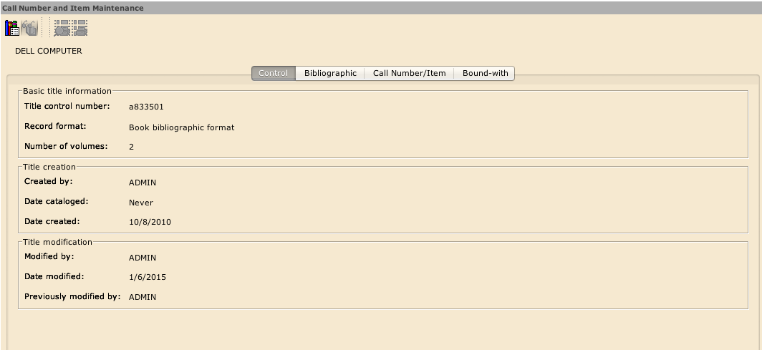

The following title control numbers are currently set to display:

MacBooks= a815149;

Dell = a833501

Dell Mini= a833586;

Study Room = a833931;

Headphones= a678415;

The simplest way to add new headphones, laptops etc. is to ensure that the item record is added to one of the preexisting bibliographic records referenced above.

Use the Call Number & Item Maintenance Wizard under the Cataloging Toolbar to search by title control number for one of the above bib records

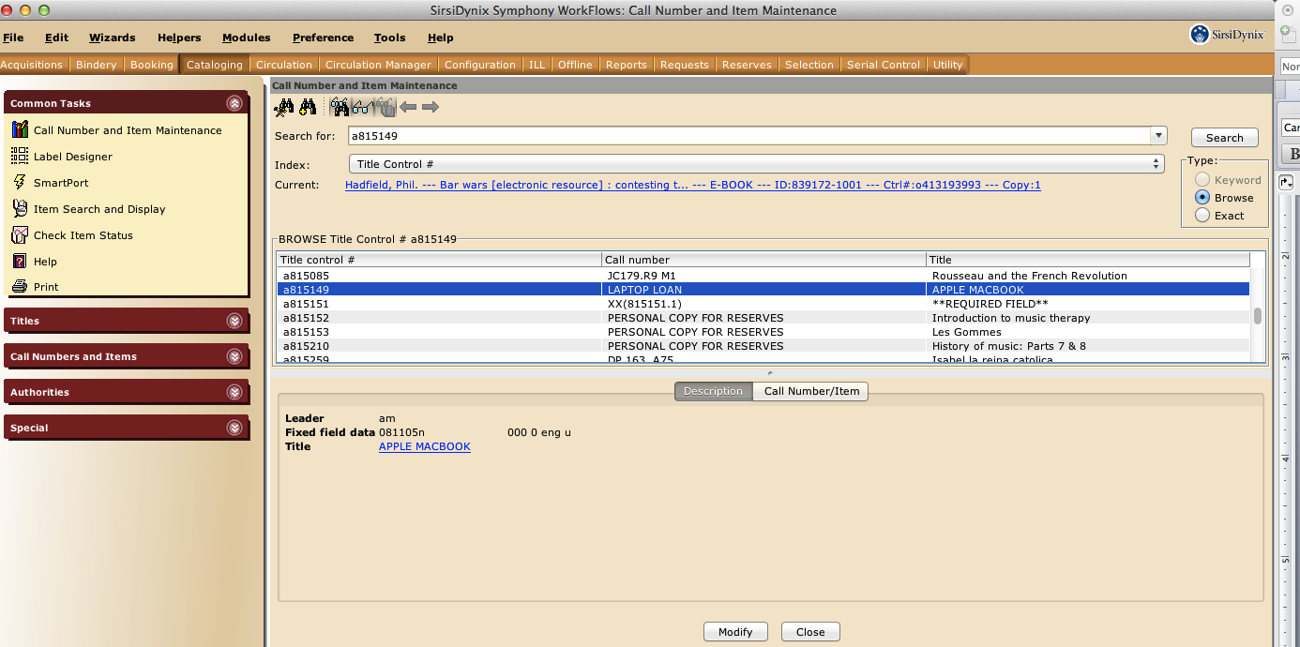

Click on Modify and Add Item

Using one of the existing item records as a template, add a new item and save it making sure you enter the correct item type and home location. You will need the barcode for the new item in order to complete this step. Alternatively you may add a dummy barcode and modify the barcode before you begin circulating the item.

Go to the Reserves Toolbar and click on Set Session Settings wizard. Set the session to LC Desk in both dropdowns.

Go to Reserve Information and Maintenance and open the Modify Reserve wizard.

Search for your new item using the title control number.

Go to the copies tab and update the reserve status to ON RESERVE. Note that the reserve status cannot be changed while the item is checked out.

To remove an item from the sign, such as when it will be taken off the desk for maintenance or if it is lost, use the Modify Reserve wizard to update the status to NOT ON RESERVE.

1. **Adding/Removing New Equipment Types to the Homepage/Digital Sign**

To add a new type of equipment to the digital sign and homepage, you need to:

Identify and/or configure the item type

Add it to the circulation map (if it is a brand new type)

Identify the title control number

See the Sirsi admin training guide if you are unfamiliar with these steps.

Follow the steps outlined above in **Adding/Removing Copies of Equipment in to the Homepage/Digital Sign** to prepare the item for display

In Dreamweaver, download the most recent copies of files in the syms directory (path is /assets/widgets/symws)

These files control the widget on the library homepage and digital sign:

symws_homepage_frontend.php—sets up the div for the homepage and creates an interval to refresh the div, currently every 5000 milliseconds

symws_homepage_backend0.html—this parses the web services request output and formats it for the div

symws_homepage_backend1.html—this parses the web services request and formats it for the div (identical copy that alternates with symws_homepage_backend0.html)

symwsfrontend.html_homepage_sets up the div for the digital sign and creates an interval to refresh the div, currently every 5000 milliseconds

symwsbackend0.html—this parses the web services request output and formats it for the div

symwsbackend1.html—this parses the web services request and formats it for the div (identical copy that alternates with symwsbackend0.html)

To make the changes open symws_homepage_backend0.html and add the new title controls and items as specified in the comments within the file. Save and post this file and then save as symws_homepage_backend1.html and replace that file as well.

Complete the same process with symwsbackend0.html and symwsbackend1.html

FYI: The web services request looks like this before it is formatted:

http://canisius.loyno.edu:8080/symws/rest/standard/lookupTitleInfo?clientID=SymWSTestClient&titleID=815149&titleID=833501&titleID=833586&titleID=833931&titleID=678415&titleID=851394&includeAvailabilityInfo=true&includeItemInfo=true&json=true&callback=?

See the SirsiSynix Web Services Guide for more information on how to utilize web services via SOAP, REST or JSON.

III. Supplemental Files